BULK EMAILING

1. Executive Summary
The Bulk Emailing solution automates high-volume emailing of NetSuite transactions—Invoices, Vendor Bills, and Bill Payments—with the right template, recipients, CC rules, and PDF attachments, all from a filterable “Process Bulk Email” page. Users can Mark All across pages (not just the current 50-row page) and the system remembers items the user manually unchecks. Selections persist per user between pagination changes, and the actual send is handled asynchronously by a Map/Reduce process that generates or picks up the correct attachment and updates each transaction’s Bulk Email Status.

2. Business Context
Barton’s AR/AP teams send hundreds of documents weekly. Before this enhancement, some customers required manually customized PDFs that forced staff to email outside of NetSuite; additionally, the legacy page required marking 50 records at a time, causing delays and errors. The new design lets teams attach a manual PDF and still use bulk emailing, and it enables true Mark All across the full filtered result set—saving time, improving traceability, and reducing the risk of missed sends.

3. Solution Overview
Components
- Suitelet (UI & search): Builds the PROCESS BULK EMAIL form with filters (Transaction Type, Invoice Type, Subsidiary, Date range, Vendor/Customer, Collection Analyst, EFT/Check) and a Mark All checkbox. It renders a paged (50-row) sublist with email columns and two “Additional Email” inputs, and wires up buttons (Search, Refresh, Mark All/Unmark All). On submit, it launches the Map/Reduce with the selected IDs and a flag indicating whether Mark All was used.
- Client Script (UX & persistence): Handles pageInit, fieldChanged, Mark All/Unmark All, pagination, and saveRecord. It persists selections per user in a lightweight custom record customrecord_bulk_email with fields like custrecord_user and custrecord_sublist_line_data, so choices survive page navigation and Mark-All workflows.
- Map/Reduce (emailing): Groups work and sends emails. It picks the email template by transaction type (Invoice/Bill/Bill Payment) and invoice subtype (Buyout/Cancel/Prepay/Time & Expense) from the Bulk Email Preferences setup record (customrecord_css_bulk_email_preference). It composes recipients from transaction and entity emails plus Contacts flagged to include in bulk email (with support for override), pulls CC from Subsidiary fields, determines the correct PDF attachment (manual vs system-generated), sends the email, and sets custbody_bulk_email_status = Sent.
Key behaviors & Rules
- Mark All across pages: The Suitelet computes the full filtered set; the Client Script stores IDs in custpage_invids and in the per-user customrecord_bulk_email holder; the Suitelet passes either the explicit selection set or the “all filtered IDs” to the MR. Unchecked items remain excluded even when returning to a prior page.
- Template selection: Standard templates per type, with overrides by Invoice Type: Buyout, Cancellation, Prepay, Time & Expense (all sourced from customrecord_css_bulk_email_preference).
- Recipients & CC:
  - Contacts where custentity_css_include_on_bulkemail = T; if custentity_override_customer_email = T, only the contact’s email is used.
  - CC pulled from subsidiary: custrecord_csa_bee (Bulk Email CC) or custrecord_csa_bpbe for Bill Payments.
- Attachments (manual vs system):
  - If the transaction’s Bulk Email Attached File (custbody_c67916_beaf) is checked and files exist, those are attached. Otherwise, the MR generates PDFs via existing Suitelets (e.g., consolidated invoice PDF or payment voucher). Vendor Bills attach only if a manual file exists.
- Status gating & filtering: The Suitelet excludes records already sent (custbody_bulk_email_status = 1), can restrict Invoice status (e.g., CustInvc:A), and respects an entity flag custentitycsa_hideon_bulkemailing.

4. Functional Flow
- Open the page: User navigates to PROCESS BULK EMAIL (Suitelet customscript_css_sl_bulk_mail_process). The form shows filters for Transaction Type (Invoice / Bill Payment / Vendor Bill), Invoice Type, Subsidiary, Start/End Date, Vendor/Customer, Collection Analyst, and EFT/Check; a Mark All checkbox is available.
- Search & list results: Clicking Search runs a backend search with paging (PAGE_SIZE = 50). The results sublist displays key fields (Date, Period, Type, Memo, Amount, Employee, Subsidiary, Customer/Vendor, Project (hidden), transaction/entity emails) plus Additional Email 1/2 inputs. A VIEW column links to each record.
- Select records (with persistence):
  - Mark All checks every filtered result (not just the current page). The Client Script caches the IDs for the current user in customrecord_bulk_email.custrecord_sublist_line_data and mirrors them to the hidden long-text custpage_invids to survive navigation; manual unchecks remain respected when returning to earlier pages. Unmark All clears the cache.
  - Users can also tick individual rows; the script updates the cached selection immediately.
- Submit (Send): On Submit, the Suitelet’s POST collects:
  - If Mark All: the consolidated invid list for the entire filtered set.
  - Else: only rows where APPLY is ticked, with any typed Additional Email values.
It then starts the MR (customscript_css_mr_bulk_email_process) with parameters custscript_marked_time_bill_ids and custscript_markedall. The user is returned to the page with a success message.
- Map/Reduce processing:
  - Input:
    - For Mark All, a search fetches each selected Invoice and constructs the payload.
    - Otherwise, the script groups selected lines by customer and gathers row details (IDs, amounts, email buckets).
  - Recipient assembly: Merge entity emails + additional emails + qualifying contacts; apply override logic when set; collect Subsidiary CC.
  - Template & body: Choose the email template based on Transaction Type and Invoice Type from customrecord_css_bulk_email_preference, then render.mergeEmail to get Subject/Body.
  - Attachment resolution:
    - If custbody_c67916_beaf = T and files exist on the transaction, attach them;
    - Else, generate the PDF via Suitelet (Invoice consolidation or Payment Voucher) and attach the resulting file. (Vendor Bills only send if a manual attachment exists.)
  - Send & update: Send email (recipients + CC + attachments). Set custbody_bulk_email_status = 1 (Sent) on each transaction to keep it off future runs.
- User experience & safeguards:
  - The results list already filters out any Sent items, and can enforce Invoice status/time windows; entities marked “hide on bulk emailing” are excluded.
  - Informational messages guide the user on submit; the page provides Refresh and Search for quick iterations.

5. Script Details

5.1 Suitelet Script — CSS SL Bulk Mail Process.js
5.1.1 Metadata & Purpose
- Type: Suitelet
- Script ID / Deployment ID: customscript_css_sl_bulk_mail_process / customdeploy_css_sl_bulk_mail_process
- Modules used: N/ui/serverWidget, N/search, N/url, N/format, N/record, N/task, N/query, N/file, and lodash.
- Purpose: Presents a “Process Bulk Email” UI to filter transactions (Invoices, Bill Payments, Vendor Bills), review recipients, optionally Mark All across pages, and submit selections to a Map/Reduce for email dispatch.

5.1.2 Request Handling
Entry point: onRequest(context) with GET (build UI) and POST (collect selections, launch MR).
- Reads request params: trantype, invtype, subsidiaryval, startdate, enddate, customerid, vendorid, analyst, check (EFT/Check), projectid/projectText, paging (page), selection persistence (ids, allinvidmark), and Mark All flag allmark.

5.1.3 UI: Form, Filters & State
Form title: PROCESS BULK EMAIL. Key filter fields:
- Transaction Type (custpage_css_transactiontypefil) with options Invoice (1), Bill Payment (2), Vendor Bill (3) (default selects current param).
- Invoice Type (custpage_css_invoicetype → customrecord_invoice_type_2), Subsidiary, Start Date, End Date, Vendor, Customer, Collection Analyst.
- Check (custpage_css_check) with values EFT (1) / Check (2) / blank.
- Mark All checkbox (custpage_css_ismarkall) to apply selection to all filtered results across pages; its default mirrors allmark.
Client script linkage: The Suitelet resolves and attaches CSS CS Bulk Mail Process.js as its client script via form.clientScriptFileId = getfileId(fileName).
Hidden/state fields:
- custpage_customerselect (hidden helper), custpage_allids (all marked IDs), custpage_trueids (line-level state), and custpage_invids (all matching internal IDs for Mark All).
Subtab & Pagination:
- Subtab TRANSACTION LIST with a Next Page selector (custpage_pagination) and fixed PAGE_SIZE = 50.
- Pagination options are computed from runPaged({ pageSize: PAGE_SIZE }); the current window is highlighted.

5.1.4 Sublist (Review & Edit Before Send)
Sublist custpage_sublist (type LIST) includes:
- Selection: custpage_checkbox (APPLY).
- Link: custpage_id (VIEW) and hidden custpage_css_internalid.
- Transaction data: custpage_css_trandate, custpage_css_period, custpage_css_transactiontype, hidden custpage_css_invtype, custpage_css_memo, custpage_css_amount, custpage_css_employee, custpage_css_subsidiary (+ hidden value custpage_css_subsidiaryval), custpage_css_customer, hidden custpage_css_projectid.
- Email targets: custpage_css_tranmail (EMAIL), custpage_css_projmail (ENTITY EMAIL), and editable custpage_css_additionalmail_1 & custpage_css_additionalmail_2.
On load, the script builds a clickable View link via url.resolveRecord and precalculates checkbox defaulting based on Mark All and prior selections (allinvidmark).

5.1.5 Data Sourcing & Filters
The Suitelet constructs a transaction search honoring filters and hiding ineligible rows:
- Always exclude customers flagged custentitycsa_hideon_bulkemailing = F (i.e., show only those not hidden).
- type derived from Transaction Type (Invoice → CustInvc, Bill Payment → VendPymt, Vendor Bill → VendBill).
- For Invoices, restrict to status CustInvc:A (open/allowed).
- mainline = T, exclude already emailed: custbody_bulk_email_status NONEOF 1 (Sent).
- Date range (with a guard ON/AFTER 2/25/2023), Subsidiary, Invoice Type, Vendor, Customer, Collection Analyst on Customer, and EFT/Check on Bill Payments via custbody_9997_is_for_ep_eft.
Returned columns populate the sublist (internal id, date, posting period, type, record type, doc no., entity, jobMain, account, memo, amount, subsidiary, emails from transaction/customer/vendor, invoice type, status, employee).
Mark All across pages: when custpage_css_ismarkall is true, the Suitelet runs getInvoiceSavedSearch(...) to fetch all matching internal IDs (not just the current page) and stores them in hidden custpage_invids and custpage_allids for POST.

5.1.6 Actions & Buttons
- Form buttons: Send (submit), Search (filterData()), Refresh (refreshPage()); Sublist buttons Mark All (markallfunction) and Unmark All (unmarkallfunction) are provided by the client script.

5.1.7 POST: Collect, Package & Launch MR
On submit, the Suitelet:
- Unpacks serialized sublist payload (custpage_sublistfields & custpage_sublistdata), where fields are delimited by U+0001 and rows by U+0002. It builds per-line objects and aggregates email targets from tranmail, projmail, additionalmail_1, additionalmail_2 into emailaddr.email[]. Only lines with custpage_checkbox = 'T' are included.
- If Mark All is on, it bypasses row parsing and passes the hidden custpage_invids list (all IDs) as a single payload element.
- Launches Map/Reduce customscript_css_mr_bulk_email_process with params:
  - custscript_marked_time_bill_ids: stringified array of selected line objects or the CSV of all IDs when Mark All.
  - custscript_markedall: boolean indicating Mark All mode.
- Renders a result page titled “Bulk Mail Process” with status “Transaction emails have been sent.” and a Go Back link that resolves to the Suitelet’s URL (url.resolveScript).

5.1.8 Helper Functions
- getfileId(fileName) searches File Cabinet to resolve the client script file id by name.
- getSavedSearch(...) / fetchSalesOrders(...) build and page the transaction dataset (runPaged({pageSize: 50})), then map the page’s rows to objects used for sublist population and the View link.
- getInvoiceSavedSearch(...) (Mark All helper) returns all matching internal IDs to persist selections across pages.
- searchAllRecord(...) / getDataFromSetupPage() generic search helpers and setup retrieval (e.g., “Advance Projects”).

5.1.9 Notable Behaviors & Assumptions
- Exclusion of already-sent transactions via custbody_bulk_email_status != 1 ensures only Pending items appear.
- Customer-hide flag (custentitycsa_hideon_bulkemailing) respected in all search modes.
- Selection persistence: with Mark All, the Suitelet stores all filtered IDs and preserves user unchecking within subsequent navigations via the hidden ID fields and client-script logic. (Design intent aligns with FDD “Mark All” requirement.)
Next sections: 5.2 Client Script (CSS CS Bulk Mail Process.js), 5.3 Map/Reduce (CSS MR Bulk Mail Process.js).

5.2 Client Script — CSS CS Bulk Mail Process.js
5.2.1 Purpose & Scope
A NetSuite Client Script that powers the front-end of the “Process Bulk Email” page: initializes the sublist, handles Mark All / Unmark All, persists selections across pagination, reacts to filter changes, validates on submit, and shuttles control back to the Suitelet with the correct parameters. Modules used: N/currentRecord, N/record, N/search, N/url, N/format, N/http, N/https, N/ui/message, N/runtime, N/query.

5.2.2 Key Globals & State
- recobj: the current record handle.
- xlist: array of currently checked line identifiers for this page/session.
- PAGINATED_REC_DATA: the master selection set (all filtered IDs) used when Mark All is enabled.
- PAGINATED_REC_ID: internal ID of the customrecord_bulk_email row used to persist selections per user.
Hidden fields used (populated by the Suitelet and read/written by the client):
- custpage_allids, custpage_trueids, custpage_invids, custpage_pagination, and the sublist custpage_sublist with checkbox custpage_checkbox.

5.2.3 Event Handlers
pageInit(context)
- Seeds xlist from hidden custpage_allids and checks the matching lines.
- If Mark All is on (custpage_css_ismarkall), pulls the full ID set from custpage_invids, then calls getPaginatedRecData to merge with any saved selection in customrecord_bulk_email for the current user. It then iterates the visible 50 rows and programmatically ticks/unticks checkboxes (uses nlapiSetLineItemValue 1.0 for speed).
- If Mark All is off, it refreshes local persisted data and clears the persisted store.
fieldChanged(context)
- Customer picker (custpage_customerselect): rebuilds the Suitelet URL (via url.resolveDomain + url.resolveScript) with current filter parameters and reloads the page.
- Pagination (custpage_pagination): saves current page’s selection into the persistent record (updatePaginatedRec), computes the target pageId, and navigates with the correct ids (empty when Mark All is on, otherwise the CSV of selected xlist).
filterData()
Collects filter field values (dates, subsidiary, transaction type, invoice type, vendor, customer, analyst, EFT/Check, Mark All) and reopens the Suitelet with those URL parameters to refresh the sublist.
markallfunction() / unmarkallfunction()
- markallfunction pulls the server-computed CSV from custpage_trueids, assigns it to xlist, and calls setValuesinSublist('ALL', true) to tick all visible rows.
- unmarkallfunction clears xlist and unticks all via setValuesinSublist('ALL', false).
saveRecord(context)
- If a global selection exists, writes it back to custpage_invids (so POST can use it) and clears the per-user custom record (so stale selections don’t linger).
- Writes xlist → custpage_allids.
- If no lines are selected, shows a warning and blocks submit; otherwise shows an information toast and allows submit.
refreshPage()
Hard reloads the window (handy after a send).

5.2.4 Helper Functions
setValuesinSublist(values, flag)
- With values === 'ALL', iterates the sublist and sets custpage_checkbox for every line.
- Otherwise, toggles only those lines whose custpage_id matches entries in values. (Used when restoring individual selections rather than a global Mark All.)
getPaginatedRecData(allinvid) → { id, data }
Fetches (or creates) the current user’s customrecord_bulk_email row and returns the saved CSV of selected IDs (custrecord_sublist_line_data). It also initializes that record with the full ID list (allinvid) the first time Mark All runs. Implemented via SuiteQL (N/query) and CRUD on the custom record.
updatePaginatedRec(id, data)
Persists the latest CSV selection into custrecord_sublist_line_data. Passing '' clears the record after a successful submit or when resetting state between pages.
runSuiteQuery(type, queryString)
Thin wrapper over query.runSuiteQL(...) used by getPaginatedRecData to find the per-user row.

5.2.5 Data Hand-off to the Suitelet (POST prerequisites)
Before submit, the client ensures:
- custpage_invids = PAGINATED_REC_DATA (full selection for Mark All mode).
- custpage_allids = xlist (manual selections for the current filters/pages).
The Suitelet’s POST then consumes these to assemble the MR payload.

5.2.6 UX, Validation & Notes
- At-least-one selection guard with toast messages via N/ui/message.
- Uses a pragmatic mix of 2.x APIs and a single nlapiSetLineItemValue call for bulk checkbox toggling performance in pageInit.
- Designed to make Mark All truly global: the full ID set is loaded into PAGINATED_REC_DATA, mirrored to custpage_invids, and selections persist across page changes using customrecord_bulk_email.
Result: The client script guarantees reliable selection persistence and clean navigation so the Suitelet + MR stack receives the exact intended set of transactions for bulk emailing.

5.3 Map/Reduce Script (CSS MR Bulk Mail Process.js)
Purpose & Scope
Automates sending bulk emails for selected transactions (Invoices, Vendor Bills, Bill Payments). For each selected transaction, it merges the appropriate email template, compiles recipients (customer/vendor + opted-in contacts), assembles attachments (existing files or generated PDFs), sends the email, and stamps the transaction as “Sent”.

Script metadata
- Type: Map/Reduce (2.x)
- Script ID: customscript_css_mr_bulk_email_process
- Description: “MapReduce for bulk email process for transactions.”

Input parameters
Read from runtime.getCurrentScript() in getInputData():
- custscript_marked_time_bill_ids — payload of selected rows (per-line details from the Suitelet) or a comma-separated list of transaction IDs when “Mark All” is used.
- custscript_markedall — boolean flag controlling the Mark All mode.

Data sourcing (getInputData)
Two modes are supported:
- Mark All = true
  - Parses the incoming CSV of internal IDs and runs a search (searchAllInvoice) to fetch the minimal dataset for each transaction (id, type, subsidiary, project, customer, email, invoice type). Each result is shaped for downstream map processing.
- Mark All = false
  - Parses the Suitelet’s JSON payload and groups rows by customer via Lodash. Emits one object per customer containing arrays of transaction IDs and related fields (tran type, invoice type, subsidiary, project, emails, etc.).

Map stage — detailed logic
1) Unpack work item
For each context value, read:
- custpage_css_internalid (transaction internal ID[s])
- custpage_css_transactiontype (“Invoice”, “Bill”, or “Bill Payment”)
- custpage_css_invtype (Invoice Type: Buyout, Cancellation, Prepay, Time & Expense — carried as list values 1..4)
- custpage_css_customerval (entity id), project id, subsidiary (id/text), and a boolean Ismarked indicating Mark All.
2) Build primary recipients
- Start from emailed fields collected in the Suitelet payload (transaction email, project email, two “additional” emails).
- If a Project exists, query contacts linked to the Project that are opted in (ct.custentity_css_include_on_bulkemail = 'T').
- If any such contact has Override Customer Email (ct.custentity_override_customer_email = 'T'), replace the recipient list with only that contact; otherwise append their emails.
- In Mark All mode, the email(s) are read directly from the emailAddresses value.
The code then de-duplicates recipients before send.
3) Build CC list from Subsidiary
- If the transaction is Bill Payment, use subsidiary’s custrecord_csa_bpbe field.
- Otherwise, use custrecord_csa_bee.
- Append any found CC to a unique list. (Logic handles both Mark All and non-Mark All shapes.)
4) Pick Email Template
Templates are maintained in a preferences record: customrecord_css_bulk_email_preference with these fields:
- custrecord_css_bep_invoice_email_tpl
- custrecord_css_bep_bill_email_tpl
- custrecord_css_bep_billpay_email_tpl
- custrecord_css_bep_buyout_email_tpl
- custrecord_css_bep_cancellation_inv_tpl
- custrecord_css_bep_prepay_inv_tpl
- custrecord_css_bep_time_exp_inv_tpl
Base template is selected by Transaction Type, and for Invoices it is further refined by Invoice Type (Buyout/Cancel/Prepay/T&E).
5) Merge subject & body
- Resolve the recipient entity object: {type:'customer'| 'vendor', id:<entityId>} based on transaction type.
- Call render.mergeEmail({ templateId, recipient, transactionId }) to get the final subject & body. (Transaction ID is the single ID in Mark All mode, or the first element of the array otherwise.)
6) Assemble attachments
For each transaction (Mark All vs non-Mark All handled):
- If the transaction has “manual attachments” flag custbody_c67916_beaf = T, then load attached files via a search (join to file) and push them into attachmentArr. Supported for Invoice, Vendor Bill, and Bill Payment.
- Else generate a PDF via Suitelets and attach returned file:
  - Invoices → call customscript_csa_sl_consolidated_pdf (customdeploy_csa_consolidate_pdf_dep) with params { poid:<tranId>, tomail:'T' }. The Suitelet returns a file ID; load it and push to attachmentArr.
  - Bill Payments → call customscript_csa_sl_generatepaymentvouch with params { custpage_billpayment_id:<tranId>, custpage_tomail:'T' }. Load returned fileId and attach.
(Logging shows invoicePDFSuitelet URL and the fetched file ID.)
7) Send email
Using email.send({ author, recipients, cc, subject, body, attachments, relatedRecords: { entityId } }).
- The author is the current user.
- The relatedRecords.entityId is set to the customer/vendor entity.
- With or without attachments, the message is sent once the recipient/cc arrays are prepared.
8) Post-send status update
After a successful send, updateTransactionRecord() stamps the transaction with custbody_bulk_email_status = 1.
- Supports single ID (Mark All) or iterates the array of IDs.
- Resolves the correct record type: invoice, vendorbill, vendorpayment.

Reduce & Summarize
- reduce: not used (empty implementation).
- summarize: wrapper present with try/catch; no aggregation is currently performed.

Error handling & logging
- Map stage is fully wrapped in try/catch; errors are logged with log.debug('Error MR Bulk email', e.message).
- Attachment generation loops include defensive try/catch with log.error('ERROR in loop', e).
- DB queries (runSuiteQL) funnel through a small helper (getQuery) that returns [] if no results.

Configuration & Dependencies
- Preferences record: customrecord_css_bulk_email_preference holds the template IDs for each transaction and invoice subtype. Keep this record populated to avoid templateId = null.
- Subsidiary fields: custrecord_csa_bee (AR/Bulk Email CC), custrecord_csa_bpbe (Bill Payment CC).
- Contact gating: ct.custentity_css_include_on_bulkemail (opt-in), with override via ct.custentity_override_customer_email.
- Manual attachments flag: custbody_c67916_beaf on the transaction.
- PDF Suitelets: customscript_csa_sl_consolidated_pdf (Invoices) and customscript_csa_sl_generatepaymentvouch (Bill Payments).

Notable behaviors / edge cases
- Recipient override: If any project contact is marked “override customer email”, all other recipients are ignored and only that contact is emailed.
- Deduplication: Final To and CC lists are de-duplicated before send.
- Transaction type mapping:
  - “Invoice” uses base invoice template or one of the specialized templates based on invoice type (Buyout, Cancellation, Prepay, T&E).
  - “Bill” and “Bill Payment” use their respective base templates.
- Mark All vs. Selective: Code branches across the entire map flow to handle single IDs vs arrays (entity object, transactionId coercion, subsidiary lookups, attachment loops).

7. Testing and Validation

7.1 Process Bulk Email: Suitelet Page, Link to Open - /app/site/hosting/scriptlet.nl?script=247&deploy=1

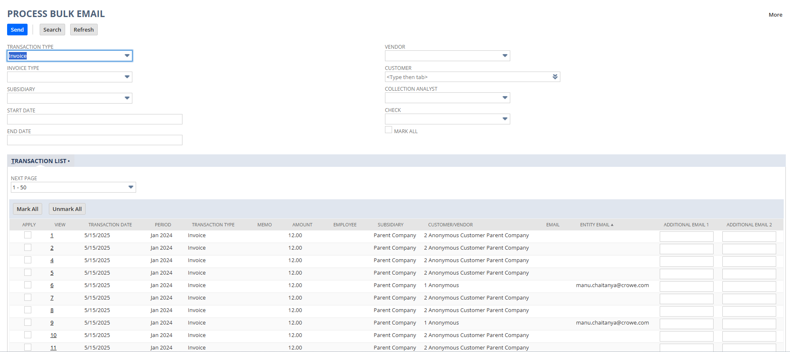

7.2 Filters on Suitelet Page: After applying these filters we get filtered transaction records.

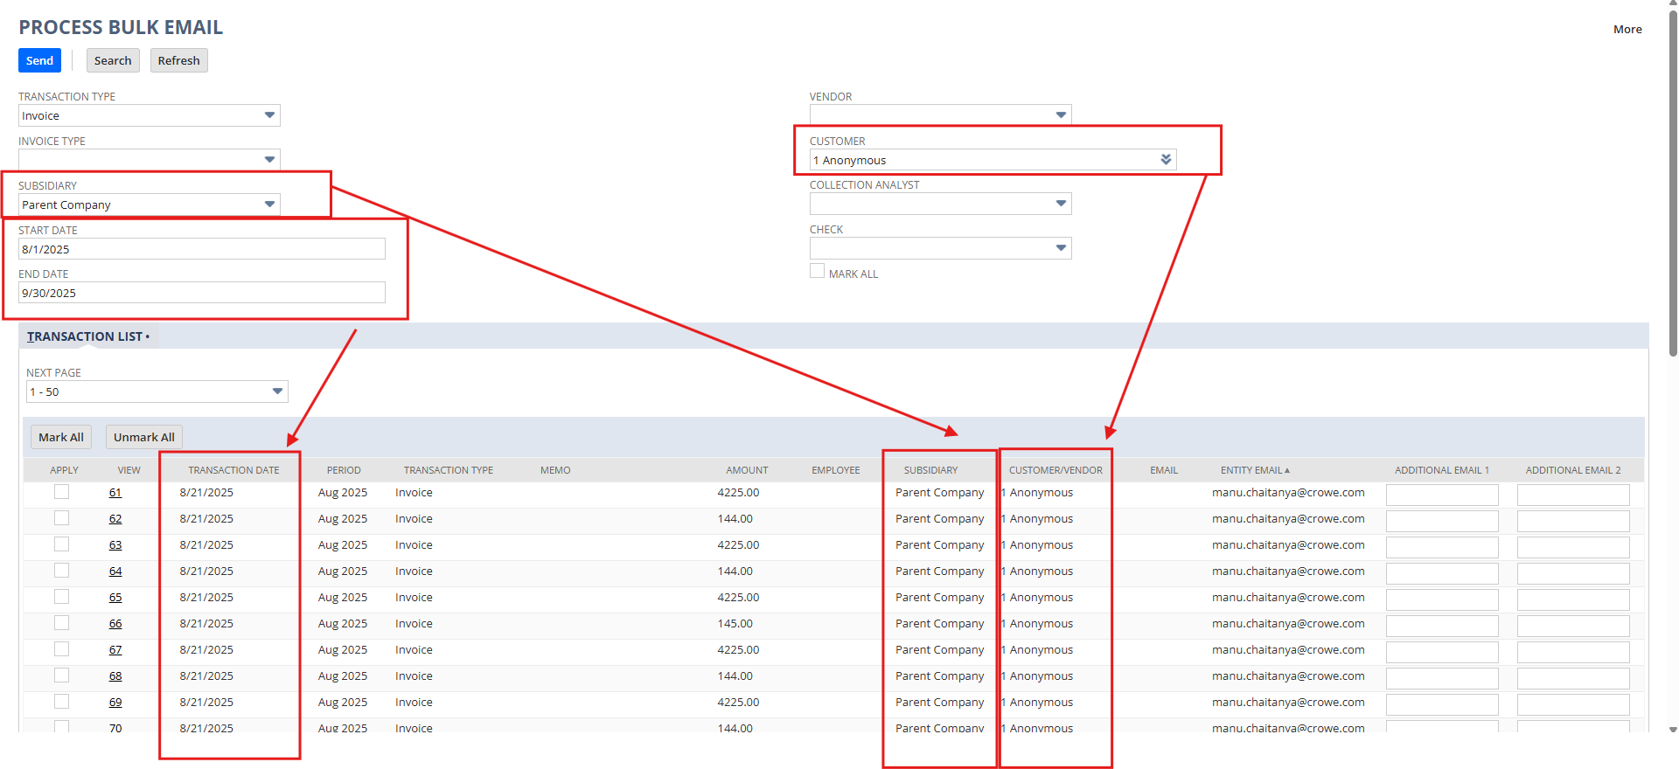

7.3 Pagination (Manual Selections)
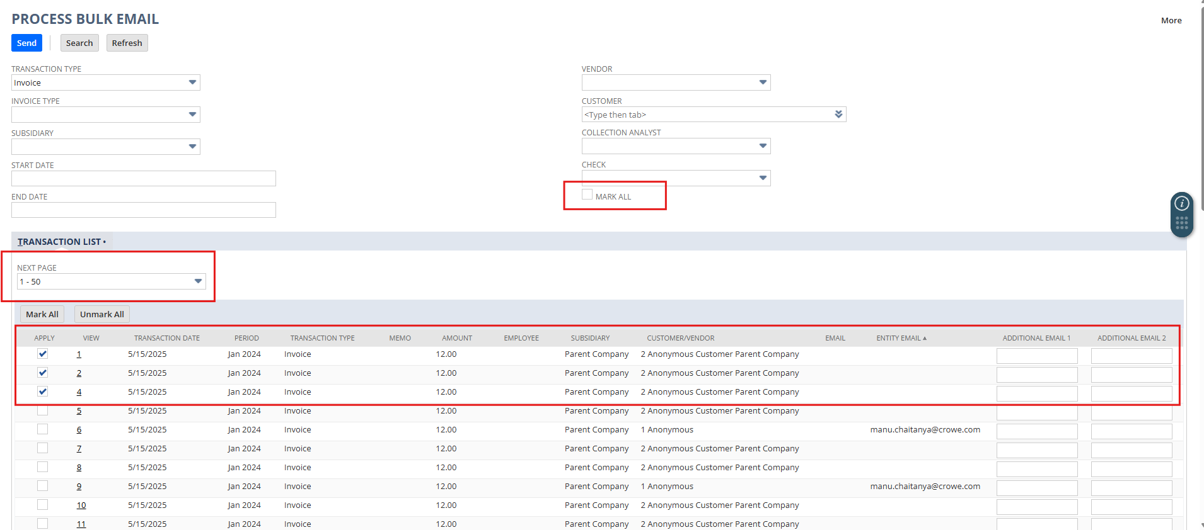

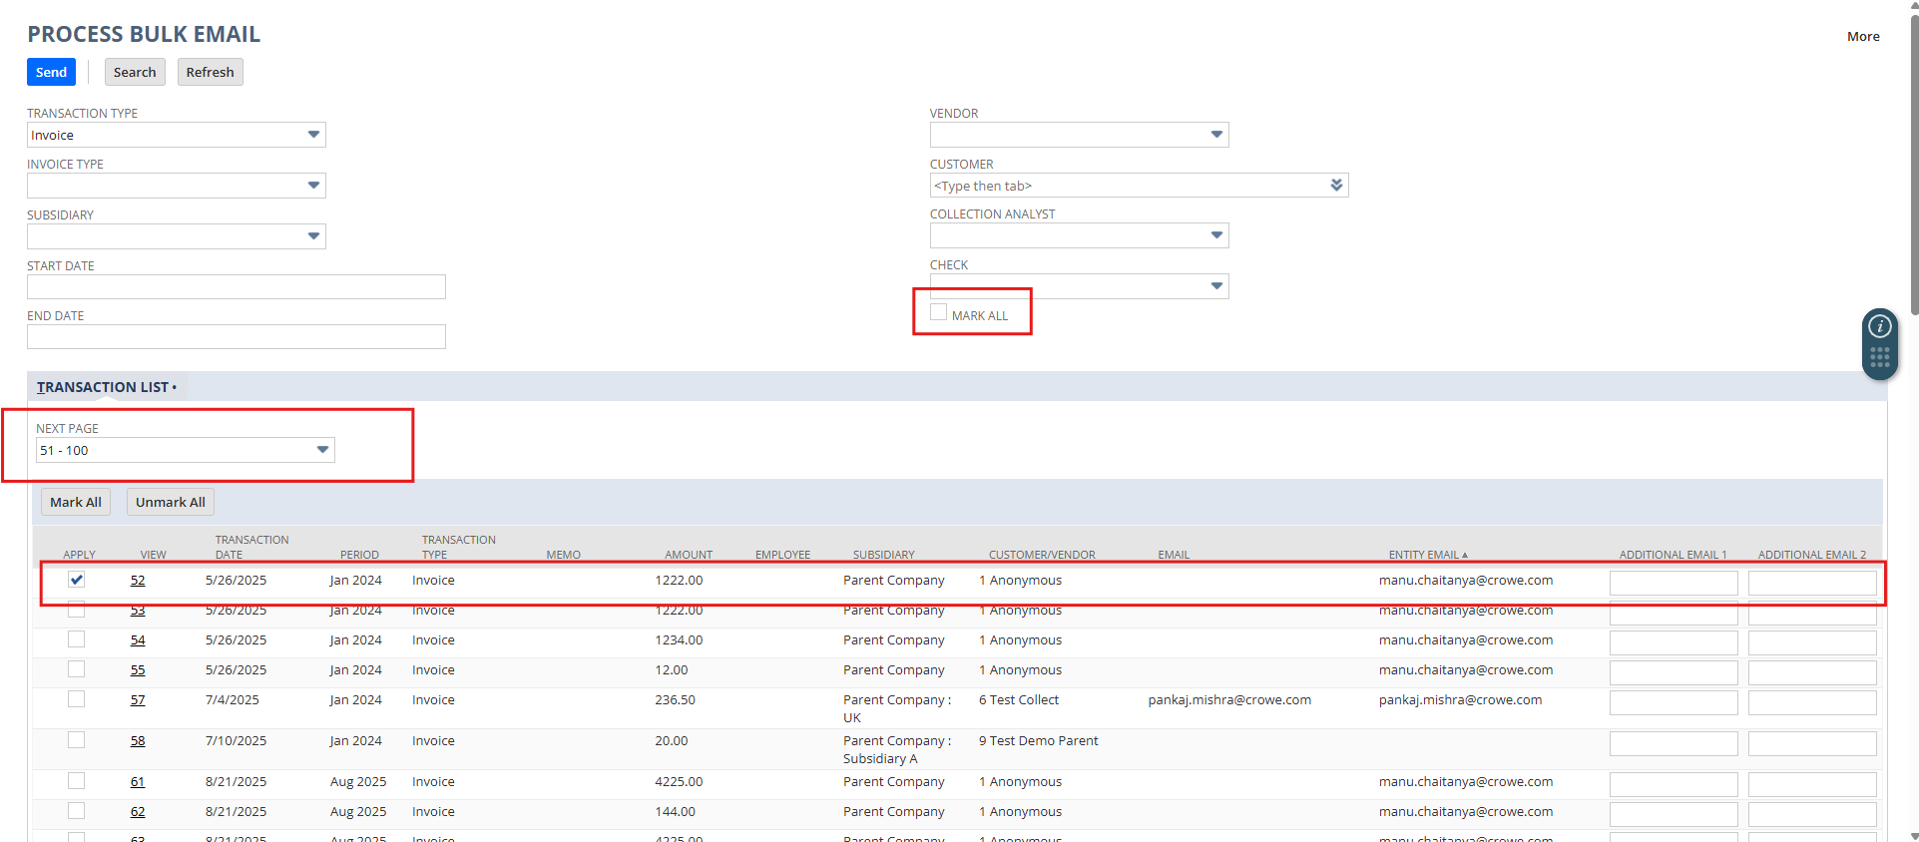

7.3 Pagination (Mark All Selections)
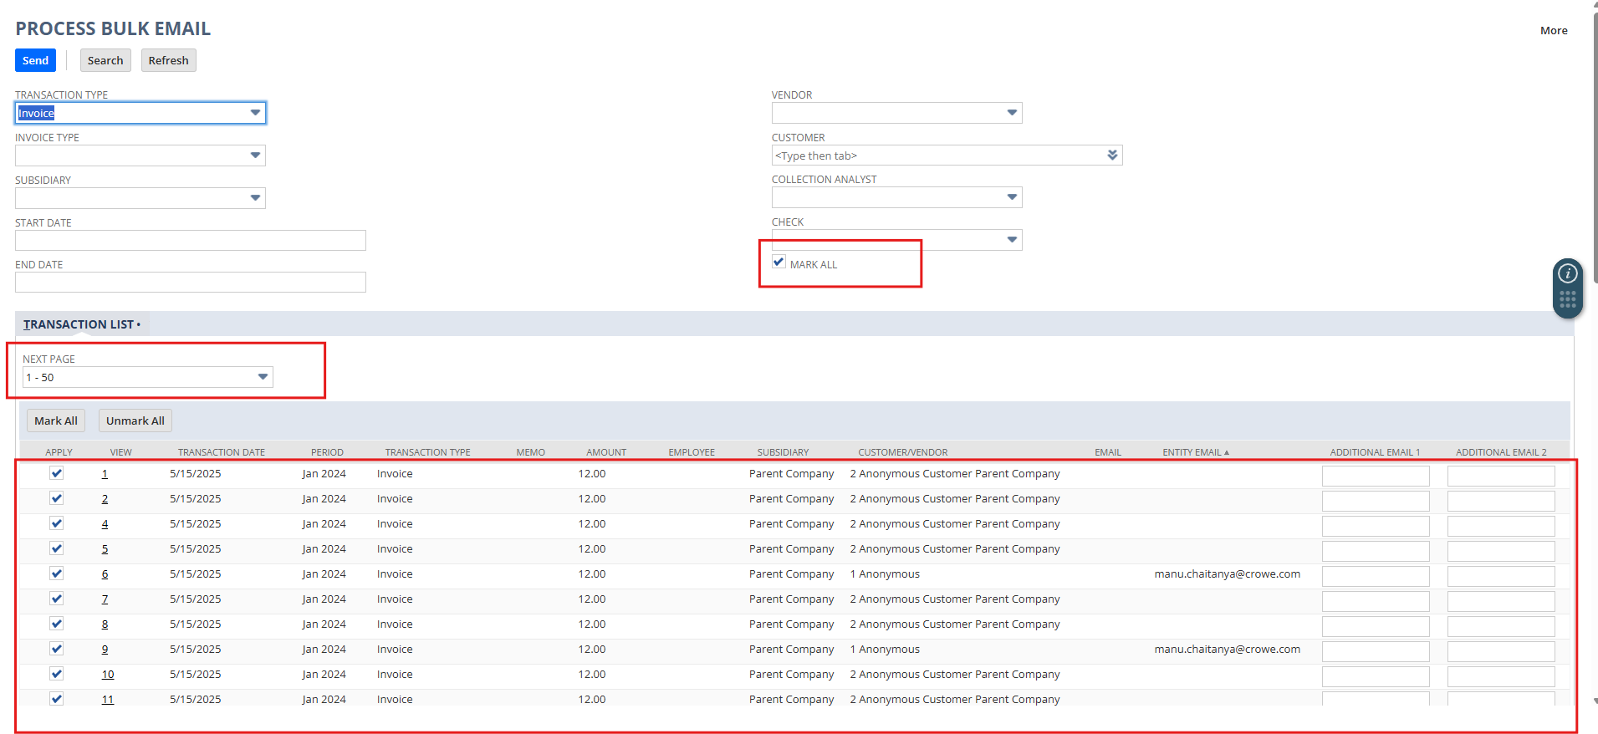

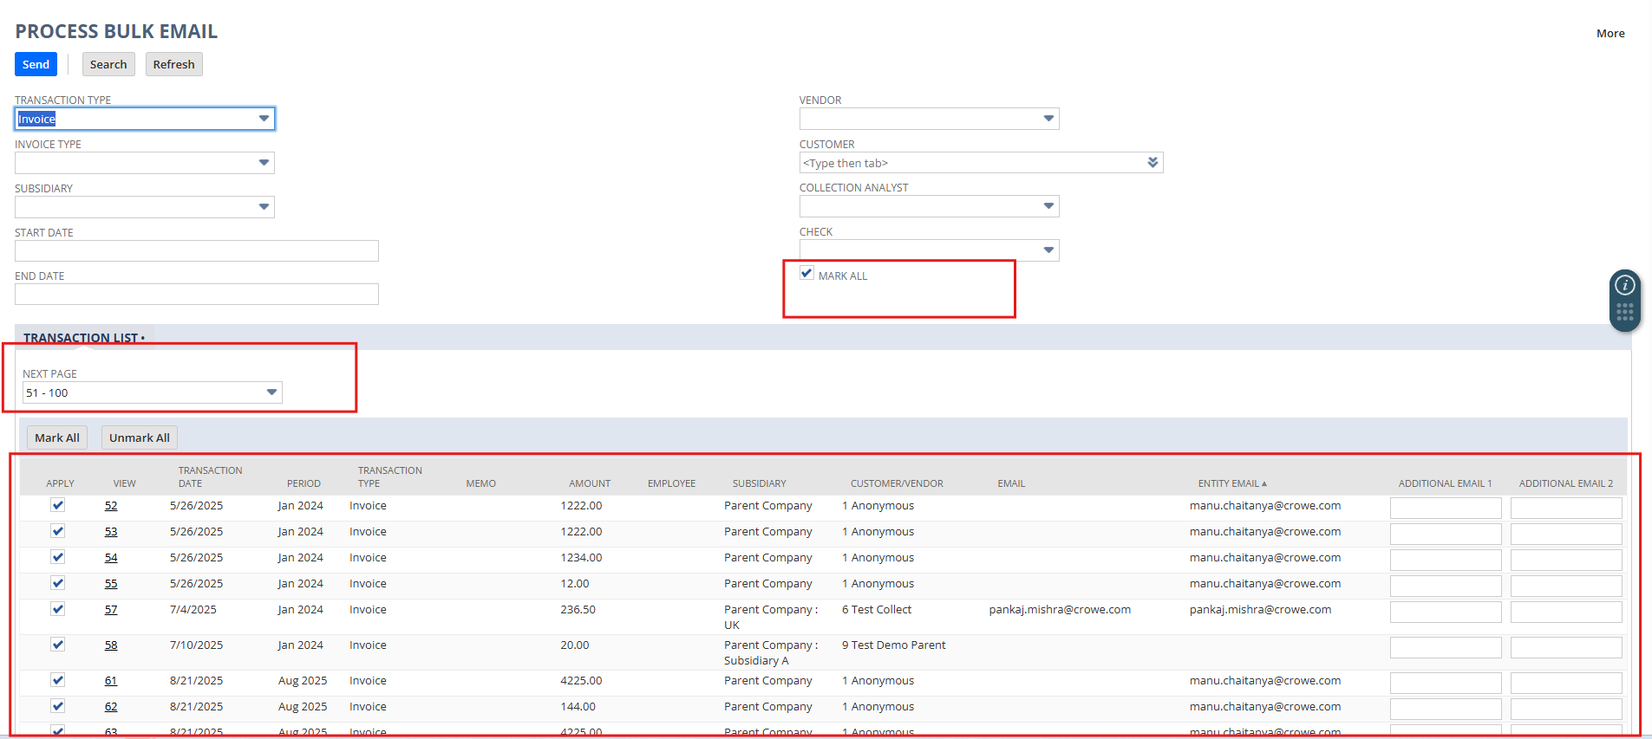

7.4 Transaction Record Configurations

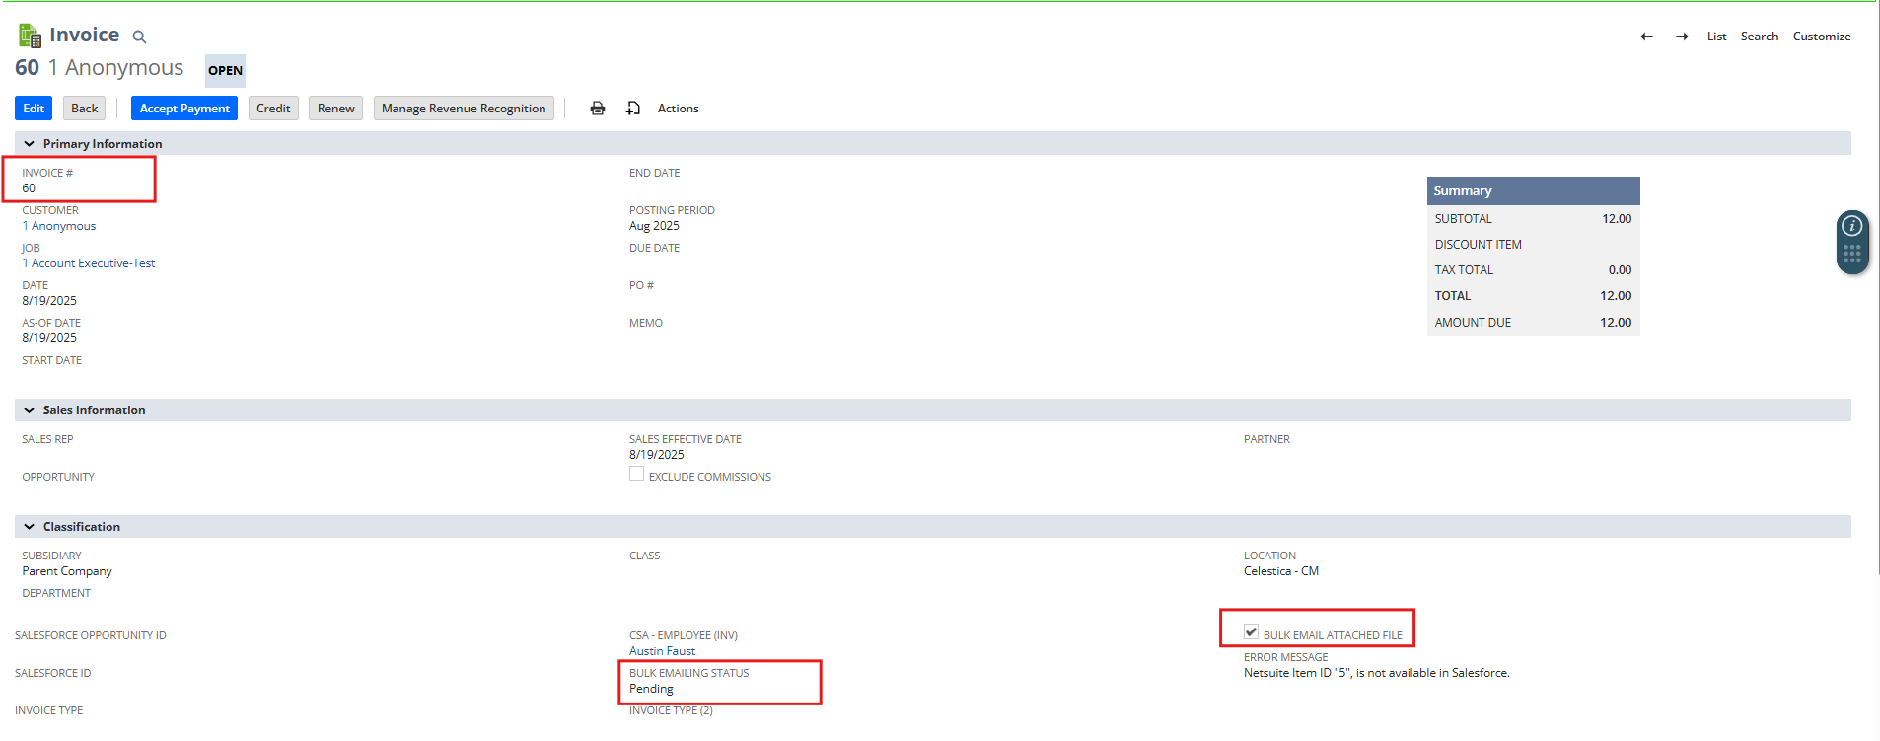

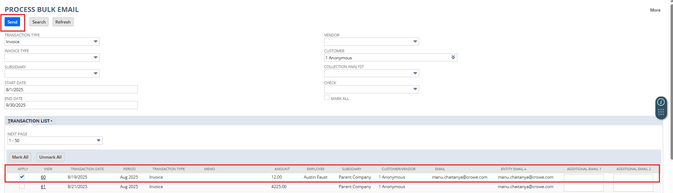

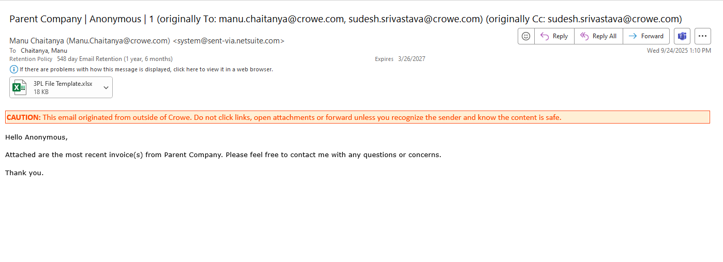
7. Result
- User confirmation & redirect. After you click Send, the Suitelet displays a success banner — “Transaction emails have been sent.” — and provides a Go Back link to return to the Bulk Mail page.
- Emails dispatched with correct content & attachments. For each selected transaction, the MR script merges the appropriate email template (based on transaction type), builds the subject/body, and sends the email to the resolved recipients. If Bulk Email Attached File (custbody_c67916_beaf) is checked on an Invoice, the script attaches the file(s) on the record; otherwise it generates/attaches the system PDF. Similar attachment handling exists for Bill Payments and Vendor Bills per their logic.
- Transaction status updated. Each processed record is stamped with Bulk Emailing Status = Sent (custbody_bulk_email_status = 1). This persists on Invoices, Vendor Bills, and Bill Payments via record.submitFields in the MR script.
- Auto-exclusion from future runs. The Suitelet’s search excludes any transaction where Bulk Emailing Status = Sent, so items you just processed are removed from the list by design.
- “Mark All” applies across pages; client-side confirmation shown. When Mark All is used, the selection spans all pages that match the filters; on submit the Client Script shows “Mass mail process been Submitted. please wait for a minute and referesh this page or view Process Bulk Mail page.” to acknowledge the action.
- Implementation note vs. FDD. The FDD requests a distinct “Sent Manual Attachment” status when custbody_c67916_beaf is used; current code sets Sent (1) universally. If reporting needs to distinguish manual-attachment sends, add the new list value and update the MR to set it conditionally.
- Vendor Bill behavior (per design). As specified, Vendor Bills are intended to send only attached documents via Bulk Emailing; if no attachment exists, no PDF is sent. (Confirm configuration aligns with this rule.)
Net effect: Users see immediate confirmation, emails go out with the right templates/attachments, transactions are marked Sent and disappear from the queue unless explicitly reset for re-send — meeting the speed, traceability, and accuracy goals of the enhancement.

